**Deployment Diagram:**

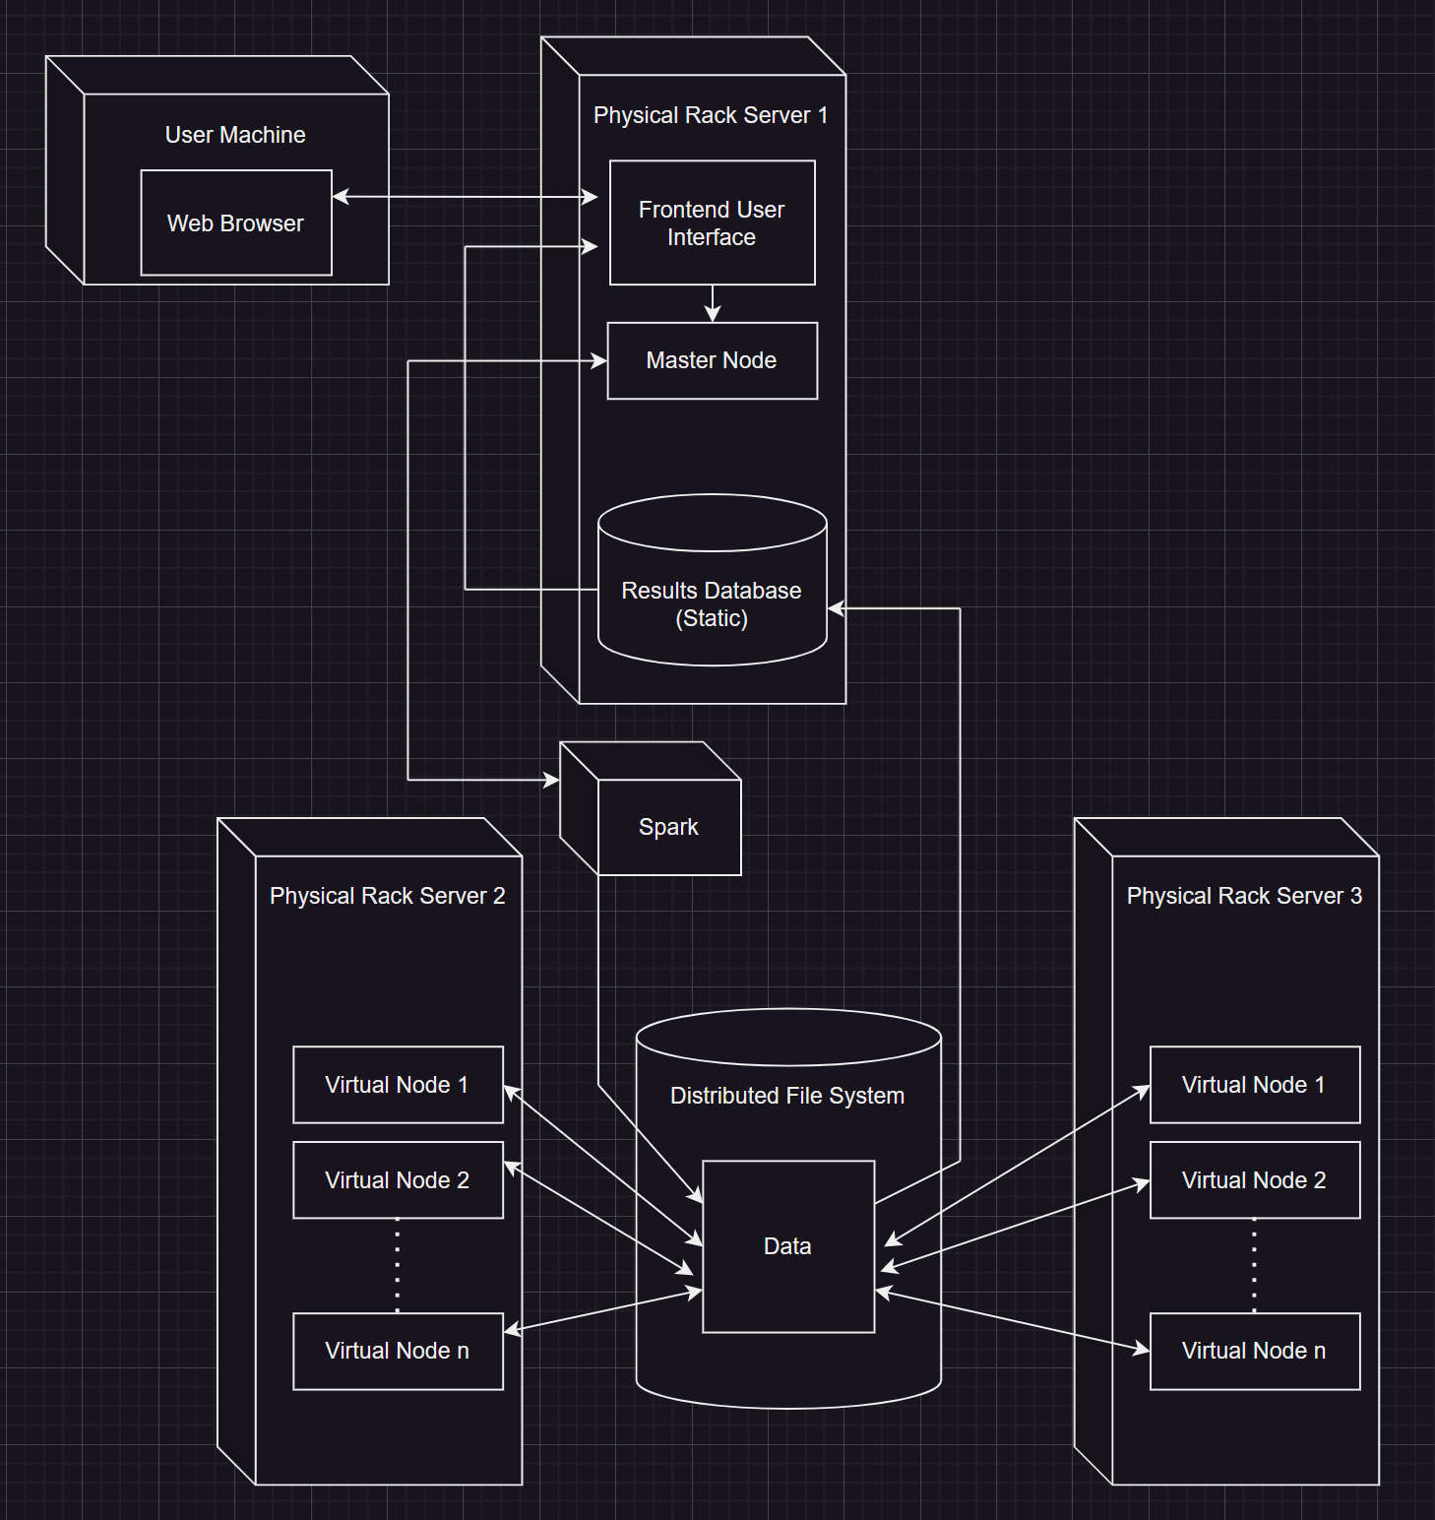

**User Interfaces:**

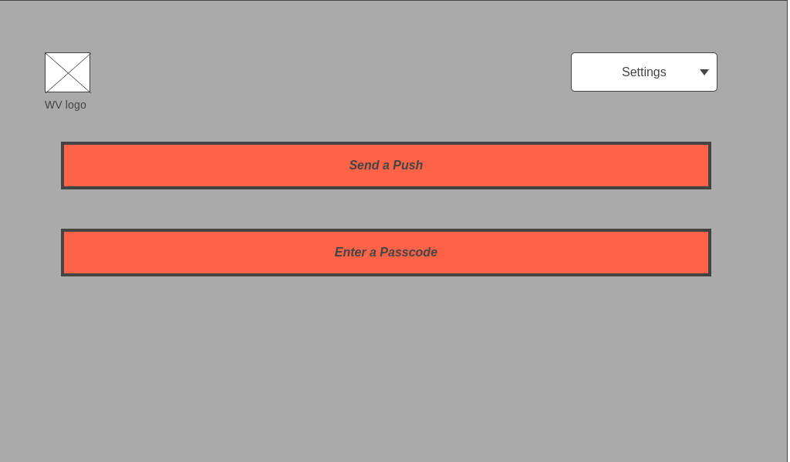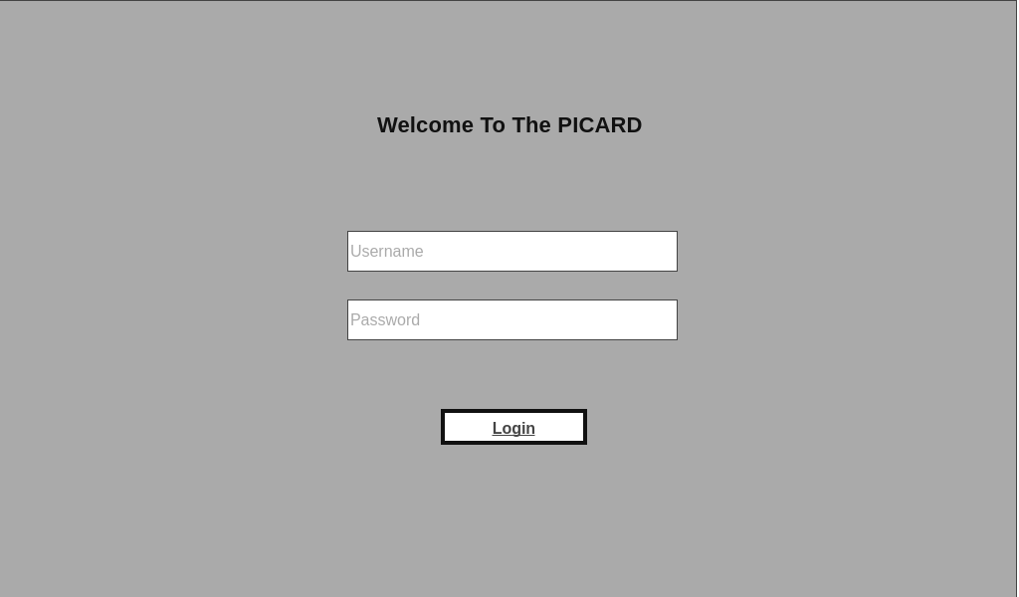

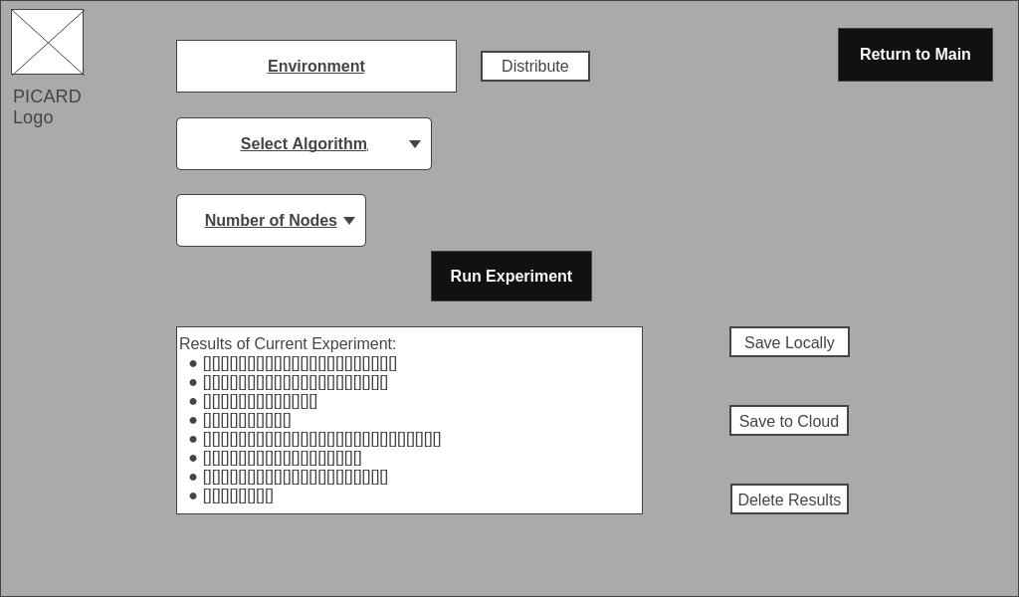

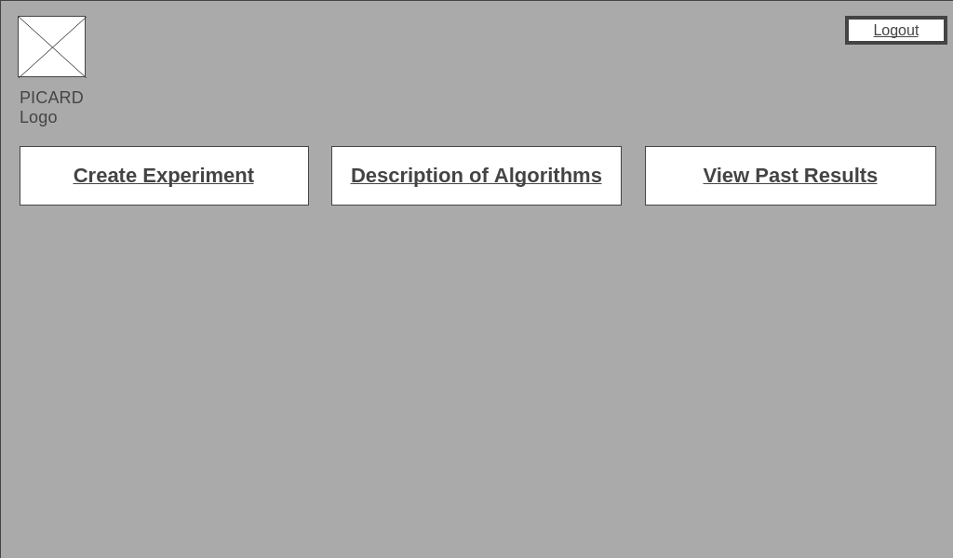

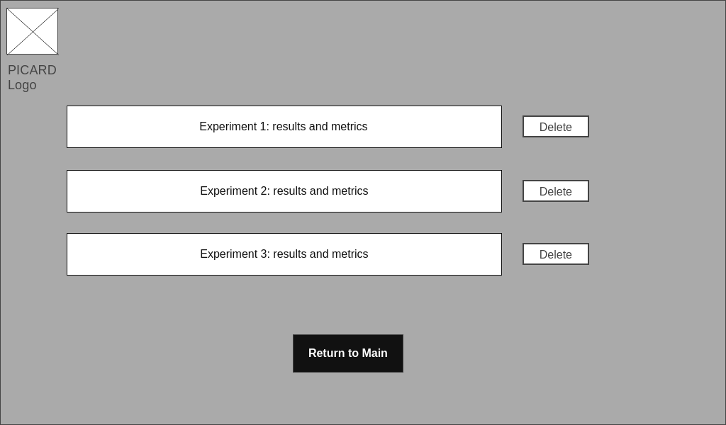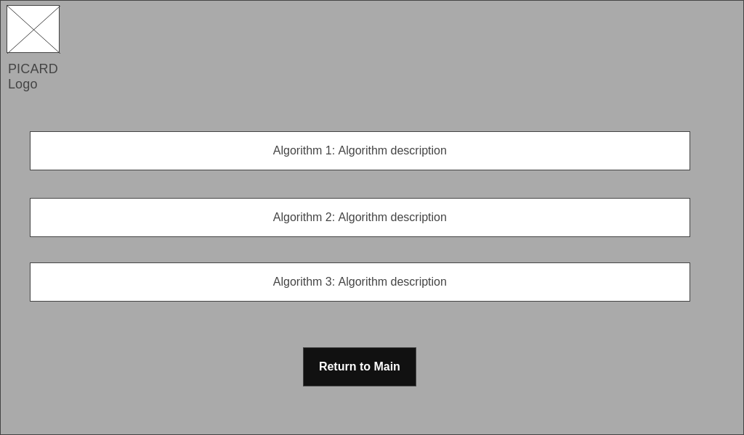

Figure 2:User Interfaces for The PICARD

**Function/Method Definitions and Database Design:**

* Login(string username, string password): boolean
  + Description: Login page for a user to start/resume session
  + Parameters:
    - Username: String value of the user in the system
    - Password: String value of the password in the system
  + Returns: Boolean Value, true on success, false on requirements for user or password being incorrect.
* Upon successful Login:
  + Description: Duo Authentication, send a push/enter a passcode
  + Parameters: Correct User Name & Password
  + Returns: True/False
* Once Logged in: Prompt the user with three options
  + Create Experiment
    - Enter Environment Parameters
      * Select Algorithm: List
        + SupervisedMLRF
        + SelfLearningMLRF
        + CoDRIFT
        + Collective
      * Number of Nodes: Integer Value
    - Run Experiment:
      * Description: Window showing the experiment running
      * Parameters: Must be logged into an account
      * Returns: Integer Value, 0 for no error, 1 for error.
    - Save to Results Database
      * Description: Button to save the data to the Results Database
      * Parameters: Must be logged into an account, Run experiment value. (Since you cannot save an experiment if the test is incomplete.
      * Returns: Boolean, True if downloaded, False if otherwise.
  + Description of Algorithms
    - Description: Prompt to new window showing algorithm’s description, value being a string, Each index in the list should have a description corresponding to list of algorithms
    - Parameters: N/A
    - Returns: String of specified index.
  + View Past Results
    - Description: Prompt to new window showing past results/metrics, values being integers
    - Parameters: Option for each Experiment to delete these results

**MySQL Database**

1. Tables:
   1. Experiment Parameters
      1. Algorithms: String Listing all algorithms
      2. Results: List of Key Value Pairs
      3. Data_Parameters
   2. Algorithms:
      1. Name: String
      2. Type: String
   3. Enviromental_Parameters
      1. Number_of_Nodes: Integer
      2. UID: Integer
      3. Executors: Integer
      4. Memory_Used: Integer
   4. Data_Parameters
      1. PercentTrain: Integer
      2. PercentTest: Integer
      3. NumClasses: Integer
      4. PercentLabeled: Integer
   5. Data_Sets_Cyber
      1. Network: Long
      2. Malware: Long
      3. Traffic: Long
   6. Data_Sets_Astro
      1. PALFA: Float
      2. GBT350Drift: Float
   7. Results_Classification_Perfomance
      1. Recall: Float
      2. Precision: Float
      3. F_Measure: Float
   8. Results_Execution_Performance
      1. SplitTime: Long
      2. TestTime: Long
      3. TrainTime: Long

**Test Plans:**

**Security:**

For the test plans, we’re going to make sure that our website is secured from the most known vulnerabilities such as DDoS attacks, Cross-Site Scripting, SQL Injection attacks, Broken Authentication, Password-based Attacks, man in the middle attacks and buffer overflows.

Furthermore, to be able to do this tests we should either do our own case scenarios by applying it manually and we’ll also use softwares like:

* SonarQube.
* Nessus.
* Semgrep.

**Performance:**

The other type of testing we’ll do is to test the performance of the PICARD which will be done after the interface is done to make sure that everything is working as it’s supposed too such as:

* Each button does what it’s supposed to do and routes to the correct page.
* User friendly.
* The speed of the process is as it should be.
* Assurance of expected outcome with test input for node algorithms.
* Use the dataset that was used by the group before us to rerun the tests again using it.
* Reliability of each solution making sure that the overall up and down time of each node and the whole system.

**Member Contribution Table:**

| Member Name | Meetings attended | Meetings missed | Contribution | Stuff done by member |
| --- | --- | --- | --- | --- |
| Abdalrahman Afifi | 3 | 0 | 100 | User interface, test plans, Final presentation |
| Hunter Lavender | 3 | 0 | 100 | Database design, final presentation |
| Travis Mueller | 3 | 0 | 100 | Deployment Diagram |
| Zachary Wildasin | 3 | 0 | 100 | Deployment Diagram, final presentation, user interface |